An Evaluation of Technology Patent Trends:

Relative to Periods of Economic Boom & Bust

Zhiyu Lin, Jingjie Ma, Thomas P. Malejko, Douglas Post, Nuo Tian, Nuoya Wu

Georgetown University

An Evaluation of Technology Patent Trends: Relative to Periods of Economic Boom & Bust

To evaluate different theories for concerning innovation and invention, there first must be some combination of attributes that measure innovative efforts. There have been several attempts at deriving a singular measure to accomplish this end state, however all have limitations in terms of their quality. Patent data analysis has become one of the more popular methods in understanding innovative efforts, which makes sense considering that patents should be a good measure of the number of inventions and ideas developed a given period. However, a common limitation is that many significant inventions were not patented. There is a tradeoff between effort spent getting a patent and effort towards creation of an even better invention. Despite this limitation, valuable information can still be extracted from trends in patent data.

**Background**

The most used model of economic growth is an exponential model based on levels of capital, labor, and productivity. The first two factors—capital and labor—have clearly defined bounds. An economy can only hold so much capital due to physical limitations (land, resources, revenue, etc.) preventing any further accumulation or growth, and it is also limited by the availability of able-bodied workers. This leaves productivity as the sole driver of continued economic growth as an economy approaches its natural limits on capital and labor.

**Productivity**

There is a lot of economic research aimed at understanding changes and trends in productivity. The factors that spark increases in productivity are vital to maintaining continued growth in a developed economy, like the United States. While the definitions of innovation and invention vary depending on the source, for the purposes of this research, technology and ideas that cause an improvement to productivity will be referred to as invention and their incorporation in production will be referred to as innovation. If research can isolate specific factors that drive invention and innovation, then economic policy makers would be able to more directly focus efforts to improve economic growth without incurring the many unforeseen economic consequences that occur with current policy.

Improvements to productivity can be seen throughout history—from the novel invention of the wheel to the automobile. One of the—if not the—most impactful inventions and innovations is the computer and its subsidiaries (i.e. the internet, personal computers, and automated production lines). Since its inception, the computer has changed manufacturing and human lifestyle dramatically. An important period from 1995 to 2001, known as the Dot Com Bubble, is characterized by huge improvements to computers; particularly the internet and home-computing industries.

The economic environment surrounding this period is very interesting. Aart Kray and Jaume Ventura (2005) outline the details of this environment in the introduction of their research article. They describe previously unobserved levels of foreign and domestic investment in the United States, unusual stock market growth and collapse, growing levels of debt and policy decisions with unclear economic consequences. These characteristics will be used as reference points for the interpretation of this research’s findings.

**Innovation & Invention**

How does one find factors that influence invention and innovation? This paper will begin to answer this question with the three most common theories for factors that influence innovation. The seemingly most logical theory is that market demand drives innovative effort. Industries with a greater demand for innovation will offer a greater financial reward for the innovation; thus inventors and entrepreneurs will focus their efforts and resources toward those objectives. However, a lot of inventions, like the steam engine, are not invented by senior scientists or engineers, but rather by employees working in the industry where the invention is necessary. There is no market demand or explanation for an idea that originates from an ordinary employee, whose only intention is to improve his immediate technical situation. This is where the remaining explanations are derived. The first is that previous inventions inspire newer inventions, and the second is that scientific discoveries spark new inventions. Again, these cannot explain all inventions, like the creation of the microchip and the use of certain chemicals in industry before understanding why the reaction is effective. There is no definite answer to this question, however many economists believe that innovation is a combination of all three theories.

**Patents**

Petra Moser (2013) wrote “Empirical analyses of historical data have emphasized the role of patent laws in creating incentives to invent, promoting innovation, and encouraging economic growth.” This is one of many studies done on the complex relationship between patents, patent laws, and innovation. Although no clear relationship has yet to be found, analyses of patent data can potentially open the door for new ideas and insights.

The study of patent trends was one of the first attempts to measure the amount of inventive effort in an industry in order to determine patents could be used as a corollary to productivity improvements. Since a patent gives the owner the sole rights to an idea or technology, the modern patent system was established around the turn of the 18th Century and was heavily relied upon to protect corporate innovation during the industrial revolution. This heavy dependence upon patents should make it a promising avenue for understanding innovative effort; however, during the information age, patents have become less prominent for popular technology-based inventions. Microchips are a great example of this trend. Many companies producing microchips during the early years of the technological revolution spent precious time and resources trying to patent each new chip, but the effort they put into patenting the invention gave competitors an edge in creating the next, faster microchip. Once companies recognized this trend, they moved towards releasing the new microchip and immediately putting all their effort into the next generation of computer chip, without spending the time and resources to obtain a patent. Many of technological inventions since have followed a similar pattern, although not as strictly as the microchip industry.

**Study Overview**

This research will analyze trends surrounding technology patents, those in the information technology and electronics categories, particularly as it corresponds to the Dot-Com Bubble (1994-2000), Financial Services and Housing Bubble (mid-2000s), the Dot-Com Bust (2001-2004), and the 2008 Great Recession. More specifically, this paper proposes five data science questions and evaluates their significance using a combination of hypothesis testing, visualization, and linear modelling.

**The Data**

**Data**

All the data used in this research study comes from the United States Patent and Trademark Office (USPTO) Database (Patents View, 2019). The data contains information about monthly patent statistics (number of patents pending, requested, issued, and abandoned) observed from January 1985 until December 2014. Bronwyn H. Hall, Adam B. Jaffe, and Manuel Trajtenberg—from the National Bureau of Economic Research (NBER)—categorized the patent information into different categories and subcategories in order to simplify and understand the data used in their (2001). Their paper also highlights some different trends and descriptive statistics of the patent data, providing good background information from which to work from. Our study uses the same categories and subcategories as established by the NBER authors.

**Exploratory Data Analysis**

Upon completing the data collection and cleaning process, we generated summary statistics (see Appendix A) along with preliminary plots to identify any trends in the data worth investigating. It was clear, almost immediately, that there was a distinct difference between patent trends before, during, and after periods of economic boom; especially in the information technology and electronics sectors. The plot below summarizes a majority of these trends:

*Figure 1. A compilation of scatter plots comparing the number of patents pending (solid dots) to the number of patents abandoned (hollow dots) for five principal categories of patents. The blue region corresponds to the Dot-Com Bubble, green to the Financial Services/Housing Bubble, and red to a period of economic bust.*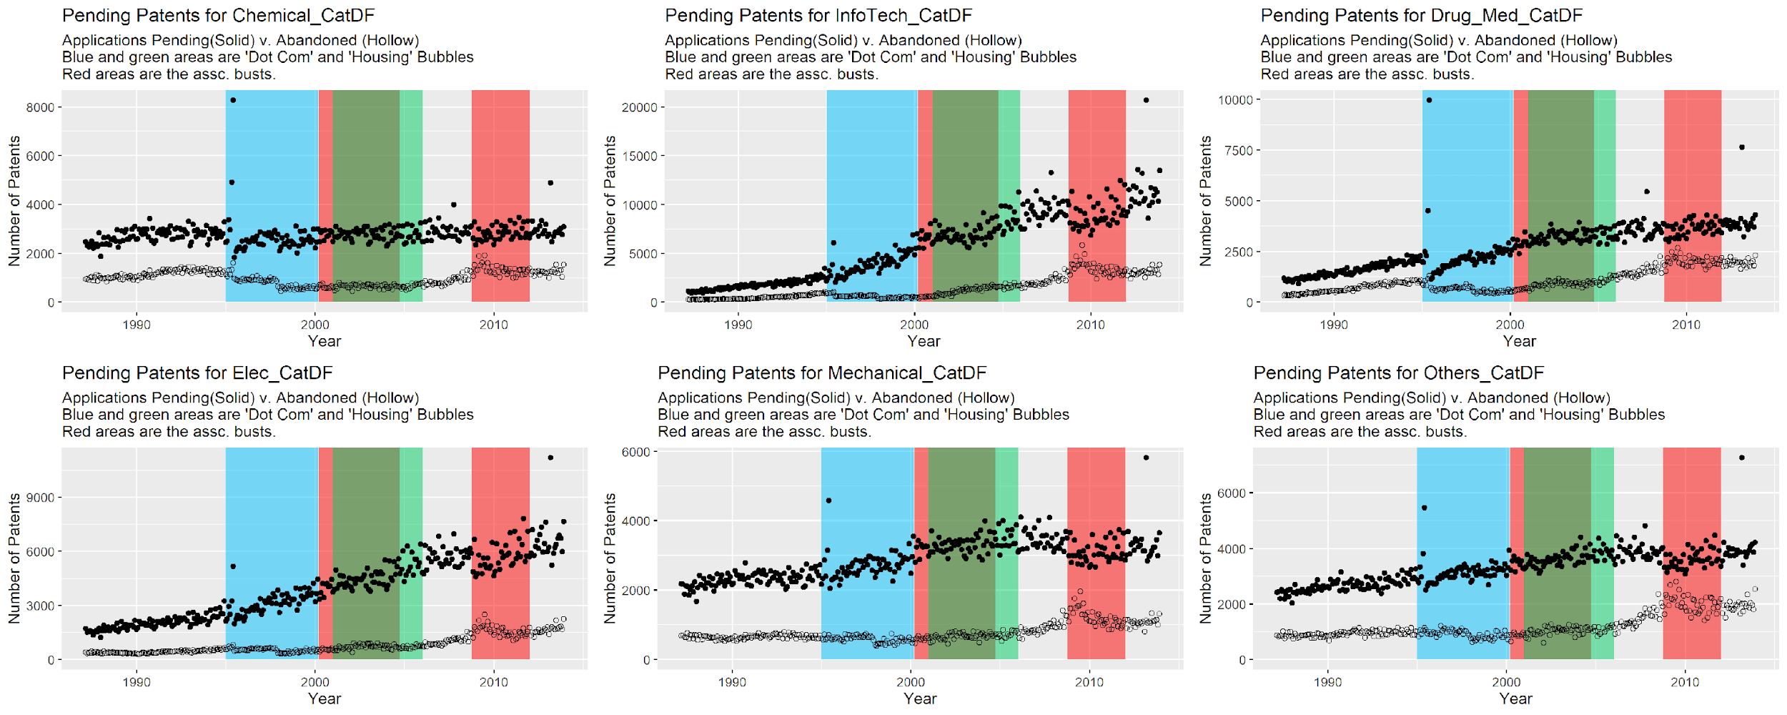

The first trend that emerged was an appreciable increase in patents pending circa 1994 in the information technology and electronics categories, which is also when many scholars believe is the start of the Dot-Com Bubble. The second trend observed was a noticeable increase in patent abandonments around the start of each period of economic bust for the same two patent categories. Finally, it is readily evident that there is a difference in the rate of patents pending for the information technology and electronics categories beginning around 1994, especially compared to more traditional economic sectors, such as the mechanical and chemical industries. As a result, we were able to narrow our focus into five principle areas:

* Is there a statistically significant difference in the number of electronic patents pending before and after 1996?
* Is there a statistically significant difference in the number of semi-conductors (a subcategory of the electronics’ category) patents pending before and after 1996?
* Is there a statistically significant difference in the number of electronics patents abandoned at the start of the Dot-Com Bust?
* Is there a statistically significant difference in the number of electronics patents abandoned at the start of the 2008 Recession?
* Evaluate changes in information technology patent trends during the ‘Dot Com’ bust.

**Visualization of the Problem**

Due to the size of our data set—which contains 322 rows of data spread across 241 variables—it simply not possibly to create plots to visualize the entire data set. Instead, plots were generated in order to better understand the five principle areas of analysis outlined above. The plots below are simple screenshots of the more interactive original graphics, which can be viewed at the following link:

<https://public.tableau.com/profile/nuo7062#!/vizhome/511_15751537895020/Story1?publish=yes>

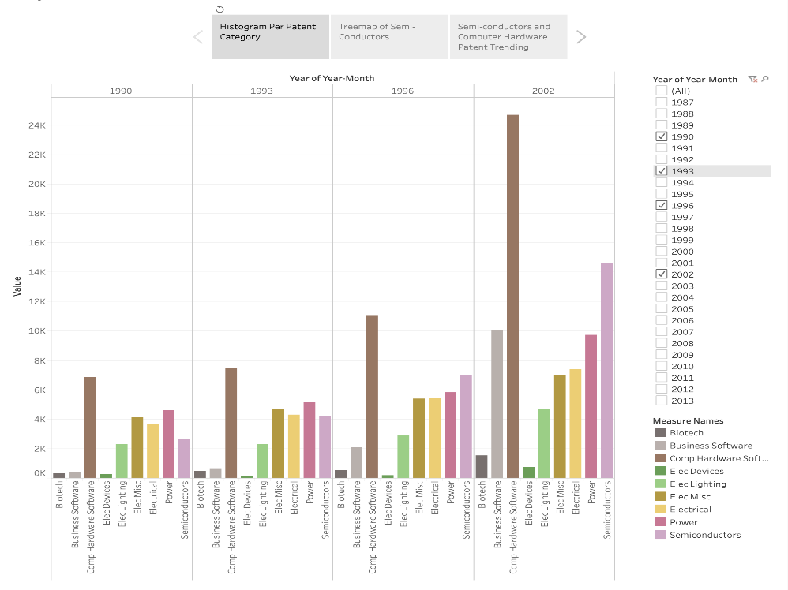

*Figure 2. Bar plots of selected patent categories separated by year.*

Figure 2 highlights the biotech, business software, computer hardware, electrical devices, and other technological related patent sub-categories in hopes of gaining a better appreciation for the changes in patents pending in those categories over time. Specifically selected for the static visualization, we choose to look at the years of 1990, 1993, 1996, and 2002 in order to see the difference before, during, and after Dot-Com Bubble. While most of the selected patent sub-categories show moderate increases in the number of requests during this time period, the quantity of business software and computer hardware patent requests soar from 1990 to 2002.

To better analyze the trends surrounding patent applications of semi-conductors (a sub-category of the electronics), a tree-map (Figure 3) was generated showing the number of applications for each year from 1987 to 2013. This plot clearly shows that the number of semi-conductor applications pending before 1996 is only one-eighth of the total population; changing form 1,315 applications to 19,094 applications in less than 30 years. Another interesting trend that this plot shows is the relative stagnation of patent applications for semi-conductors beginning in the mid-2000s. This observation could support a growing theory in economic research that suggests technology companies are moving away from patents since new the length of time it takes to gain a patent would make the technology more than obsolete by the time the company’s rights to it are protected. 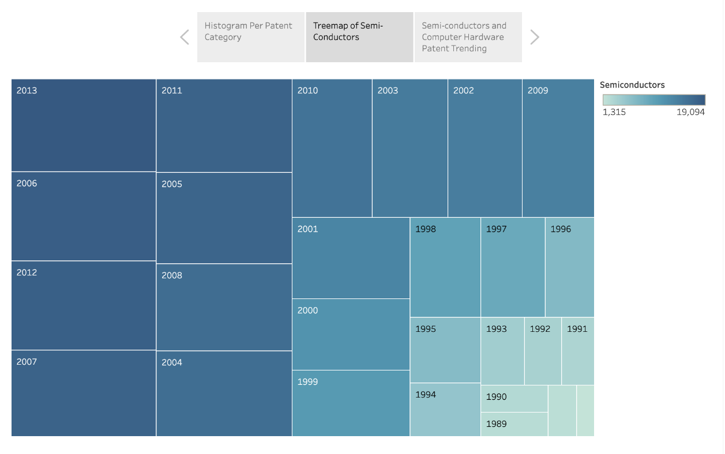

*Figure 3: Tree Map of semi-conductor patent applications from 1987 to 2013*

*Figure 3: Overlapping line plots of abandoned patent for computer hardware (tan) and business software (brown)*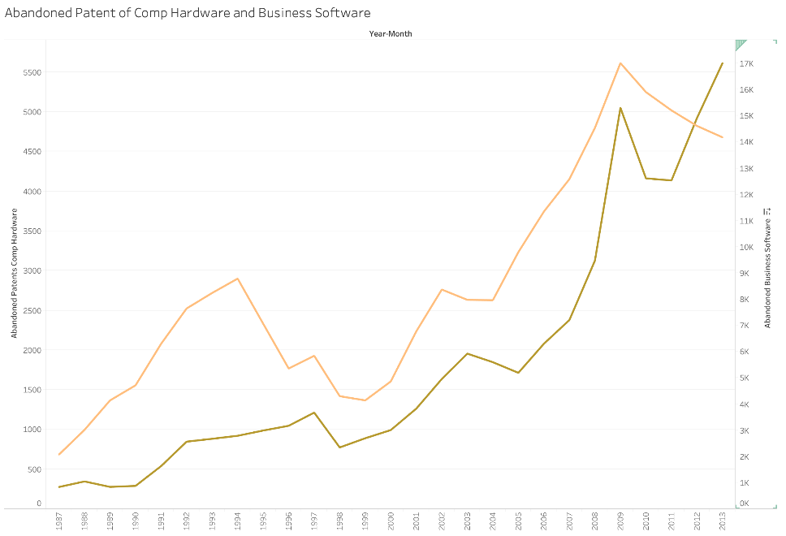

*from 1987 to 2013*

Figure 3 compares the rate of patent abandonment for computer hardware (tan) and business software (brown) from 1987 to 2013 in hopes of better identifying any trends around period of economic bust. Figure 4—below—provides a similar look, only focused at the two periods of economic bust. As evidenced by these figures, the rate of patent abandonment decreases at the start of the Dot-Com Bubble (circa 1994) and, to the contrary, the rate of patent abandonment for these sub-categories increase from the start of the Dot-Com Bust through the 2008 Great Recession. What is equally interesting is the slight growth in patent abandonments for these industries around 1998-1999, which is before the start of the Dot-Com Bust. Perhaps this slight uptick is a warning sign of the impending economic change.

*Figure 4: A more focused comparison of the previous plot, with an emphasis on the Dot-Com Bust (left) and the* 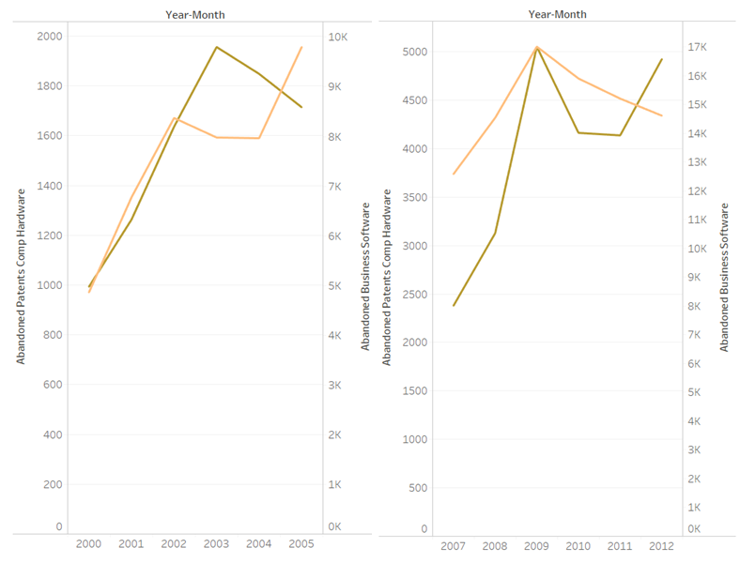

*2008 Great Recession (right).*

Figure 5, which looks at the number of patent applications for semi-conductors and business software over time, highlights a similar trend as the previous two figures. First, the rate of patent applications increase during periods of economic prosperity (1994-1999 and 2003-2007) with appreciable decreases in patent applications during periods of economic bust, which is particularly evident for the requests surrounding business software.

*Figure 5: A comparison of patent applications for semi-conductors (red) and business software (pink).*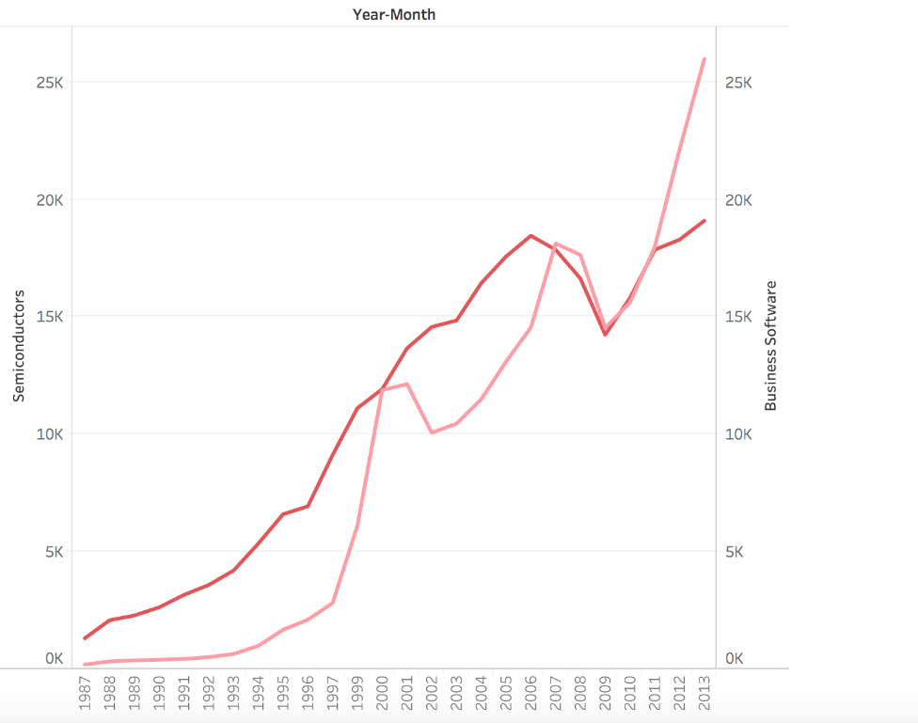

**Feature Engineering**

Four new attributes were created from this data to develop additional insights or make the results more accurate and readily interpretable. The first two changes revolved around gaining better insights into the changes each month to the number of patents pending and the number of patents currently in use. These features were derived from the existing ‘pending’ and ‘in use’ variables for each patent category and sub-category. The two attributes added to improve intractability to the linear models were ‘abandon rate’ and ‘1996-time-flag.’ The abandon rate is the ratio of the number of abandoned patents to the number of issued patents while the 1996-time-flag indicates whether the observation is before 1996 or after 1996.

**Methodology**

**Statistical Analysis**

In this section, the afore-referenced observations will be analyzed using a variety of hypothesis testing, regressions, and other statistical methods. For the first four observations, visualizations will be used to highlight the trend and provide preliminary insights into the analysis. Since the distributions of both patent applications and abandoned patents are not normal, t-tests and confidence intervals will be used to evaluate the statistical significance of the first four observations, while bootstrap sampling will be used to evaluate the fifth observation. The t-test is used to check whether the means of computer and electronic applications are the same before and after 1996. Also, 95 percent confidence intervals will show the differences of means. For the last observation, a bootstrap method will be used. The information and technology patent applications will be separated into three-time frames, namely, before April 1, 2001 (Dot-Com Bubble), from April 1, 2001 to February 1, 2003 (Dot-Com Bust), and after February 1, 2003 (after the Dot-Com Bust). A 95 percent confidence interval for a difference in mean will be generated based on 10000 random bootstrap sample.

**Linear Models and Comparison**

Two linear models for predicting the total number of pending computer and electronics patents will be proposed and assessed. The first linear model uses the number of changes in pending patents, the number of issued patents, the number of abandoned patents, the number of changes in in-used patents, the abandon rates, and the time-flag to predict the total number of pending applications. The second linear model uses the number of changes in pending patents, the number of abandoned patents, the number of issued patents, and the time flag to predict the total number of pending applications.

For model comparison, an ANOVA test and the Akaike Information Criterion   
(AIC) will be employed. The ANOVA test shows whether adding more attributes to the model will significantly improve the model fit, while the AIC estimates the out-of-sample prediction error of certain model using the maximum value of the likelihood function. Therefore, a smaller AIC score is preferred.

**Results and Interpretations**

**Observation 1**

Is there a statistically significant difference in the number of electronic patents pending before and after 1996?

***Visualization.***

The difference between the difference in mean for pending electronic patent applications before and after 1996 is made clear by the side-by-side boxplot below. 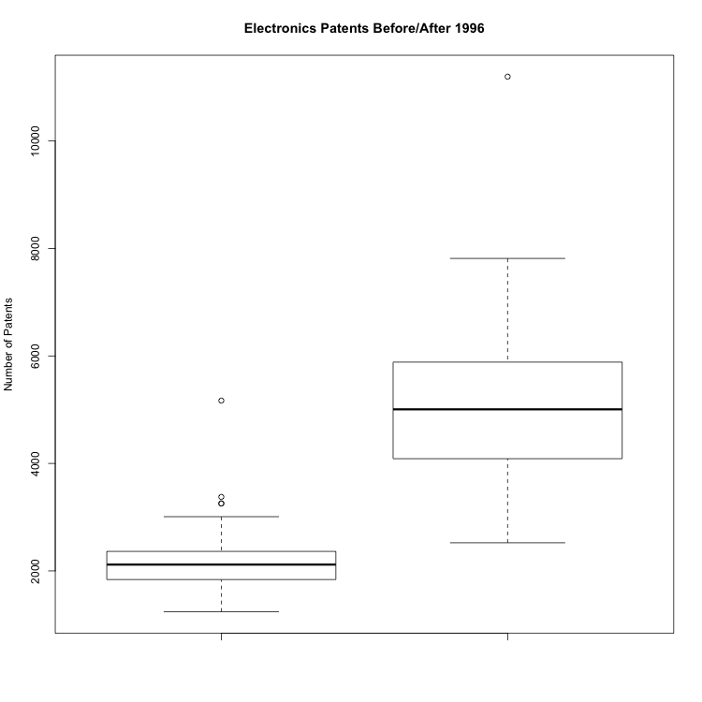

*Figure 6. Side-by-side boxplot comparing the number of patent applications in the electronics category before 1996 (left) and after 1996 (right).*

***Hypothesis testing: t-test and confidence interval results and interpretations.***

The null hypothesis for this t-test is that the mean number of total pending electronics patents are the same before and after 1996, while the alternative hypothesis is that they are not equivalent. The p-value of the resulting t-test is less than 2.2x10-16, which means we can reject the null hypothesis at the 99 percent confidence-level and conclude that the mean number of electronics patents are not the same. To further evaluate the statistical significance of the results, a 95 percent confidence interval was calculated. The resulting interval— [-3023.134, -2637.685] —does not include zero, which means we are 95 percent confident that the difference of means are different for the period before and after 1996.

**Observation 2**

Is there a statistically significant difference in the number of semi-conductors (a subcategory of the electronics’ category) patents pending before and after 1996?

***Visualization.***

The difference between the difference in mean for pending semi-conductor patent applications before and after 1996 is made clear by the side-by-side boxplot below, specifically that the number of patent applications increased following the Dot-Com Bubble. 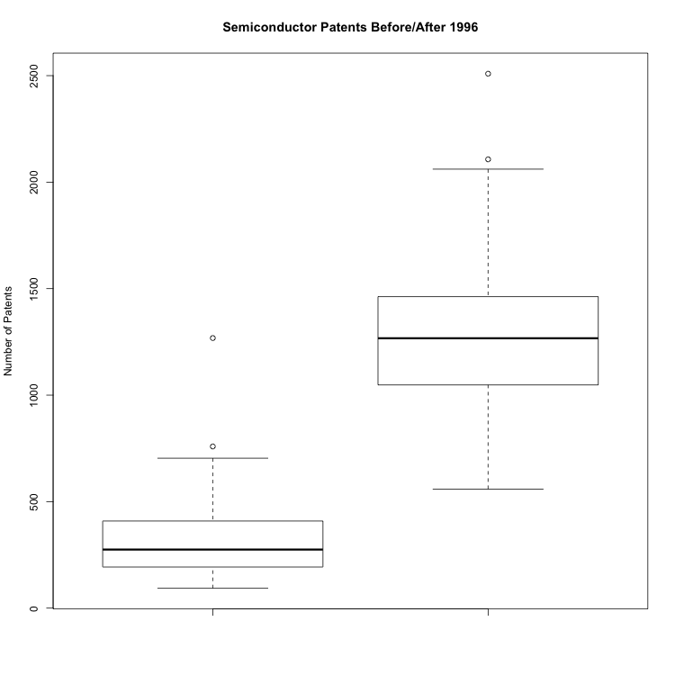

*Figure 7. Side-by-side boxplot comparing the number of patent applications in the semi-conductor sub-category before 1996 (left) and after 1996 (right).*

***Hypothesis testing: t-test and confidence interval results and interpretations.***

The null hypothesis for this t-test is that the mean number of total pending semi-conductor patents are the same before and after 1996, while the alternative hypothesis is that they are not equivalent. The resulting p-value was less than 2.2x10-16, which means we can reject the null hypothesis with 99 percent confidence. To further complement this analysis, a 95 percent confidence interval was generated. The resulting interval— [-992.342, -885.741] —does not include zero, which means that we are 95 percent confident that the difference of means are different for the period before and after 1996. In other words, we are 95 percent confident that the difference between the average number of applications before 1996 and the average number of applications after 1996 are negative for the semi-conductor sub-category.

**Observation 3**

Is there a statistically significant difference in the number of electronics patents abandoned at the start of the Dot-Com Bust?

***Visualization (for Observations 3 and 4).***

As is evident in the scatter plot below, there is a slight increase in the patent abandonment rate beginning around 1999, which corresponds to the Dot Com Bust, and a much more substantial increase around the start of the 2008 Great Recession

*Figure 8. A scatter plot depicting rate of patent abandonment for the electronics category from 1987 to 2013***.**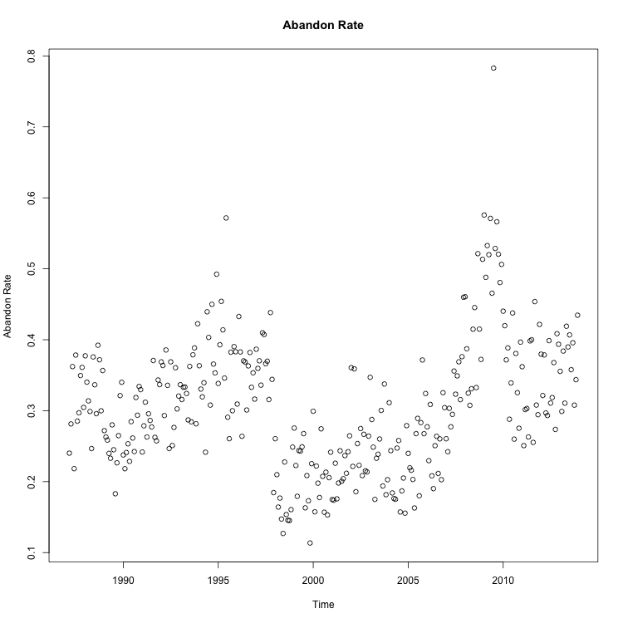

***Hypothesis testing: t-test and confidence interval results and interpretations.***

The null hypothesis for this t-test is that the mean number of abandoned electronics patents are the same before and after 1996, while the alternative hypothesis is that they are not equivalent. The p-value of this two-sample t-test is 0.0003, which means we can reject the null hypothesis at the 99% confidence level. Therefore, the data has enough evidence to support the theory that the average abandon rate has changes after the Dot-Com Bust for the electronics category of patents. Additionally, the calculated 95 percent confidence interval for this data subset is [-0.061, -0.018], which indicates that we are 95 percent confident that the difference of means before and after the Dot Com Bust is not the same.

**Observation 4**

Is there a statistically significant difference in the number of electronics patents abandoned at the start of the 2008 Recession?

***Visualization.***

See Figure 8 and its associated section for the initial interpretation of results.

***Hypothesis testing: t-test and confidence interval results and interpretations.***

The null hypothesis for this two-sample t-test is that the average rate of abandonment for electronics patents are the same before and after the Financial Services Bust, while the alternative is that they are not the same. The corresponding p-value is 2.9x10-15, which is less than 0.01; therefore, we can reject the null hypothesis. This data provides enough evidence to show that the average abandon rate changed after 2007. Additionally, the 95 percent confidence interval is [-0.135, -0.087]. We are 95 percent confident that the difference in average abandon rates before and after 2007 is negative, therefore we can conclude that the average abandon rate increased after 2007.

**Observation 5**

Evaluate changes in information technology patent trends during the ‘Dot Com’ bust.

***Bootstrap results and interpretation.***

In the bootstrap procedure, we divided the data into three-time-frames—before April 1, 2001, from April 1, 2001 to February 1, 2003, and after February 1, 2003. For any two time periods, we get the difference of means of the total number of pending information and technology patent from 10000 random bootstrap samples.

The 95 percent confidence interval of the difference of average information and technology patent applications before and after April 1, 2001 is [3443.686, 4140.253]. Thus, we are 95 percent confident that the actual difference of means is within the interval and, therefore, we can conclude that the average number of applications decreased after April 1, 2001. The 95 percent confidence interval of the average number of information and technology patent applications before and after February 1, 2003 is [-2935.524, -2114.713]. We are 95 percent confident that the true difference of means falls into the interval and, therefore, there is an increase in average patent application after February 1, 2003. Therefore, there is a decrease in information and technology patent application from April 1, 2001 to February 1, 2003.

***Linear Models and Comparison: Two Linear Models***

We proposed two different linear models in this section. The predictors in the first model are the number of changes in pending patents, the number of issued patents, the number of abandoned patents, the number of changes in in-used patents, the abandon rates, and the time flag, to predict the total number of pending applications. All predictors have positive coefficients except the number of changes in in-used patents and the time-flag for before 1996. Also, all predictors are significant except the number of changes in pending patents and the number of abandoned patents. For the second model, all predictors are significant except for the number of changes in pending patents. Also, only time flag before 1996 has negative coefficients. The 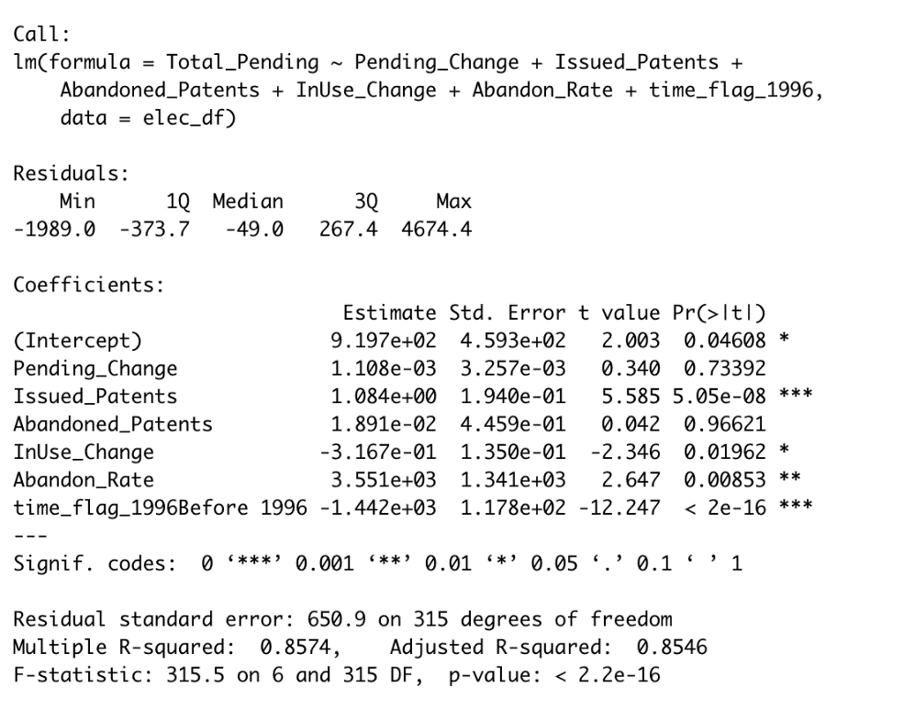detailed results of linear regression is shown as follows.

*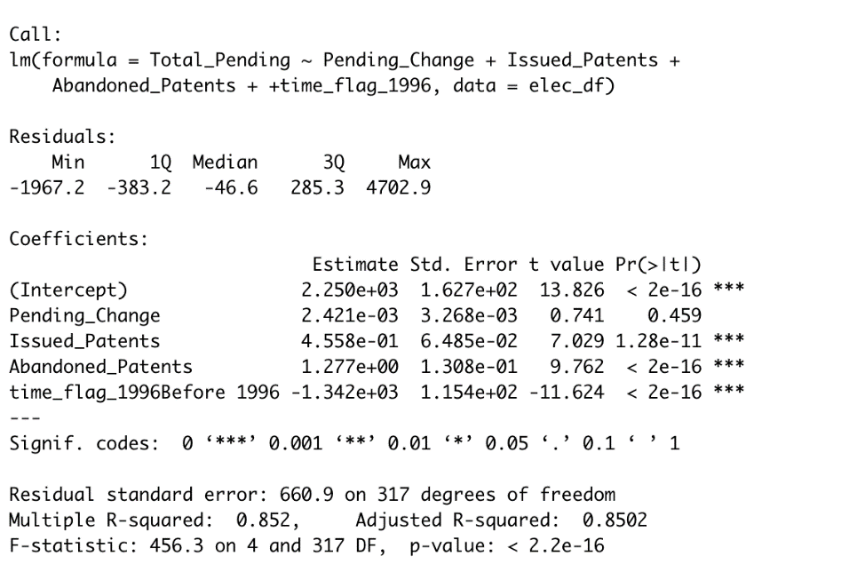Table 1: Linear Regression Summary of the first model*

*Table 2: Linear Regression Summary of the second model*

***Linear Models and Comparison: Model Comparison***

In order to check whether it is appropriate to use ordinary least square model in this case, we check the residuals before the model comparison process. Though residuals are not perfectly distributed around the zero-residual line, there is no clear pattern of all residuals. Thus, using linear models are appropriate. 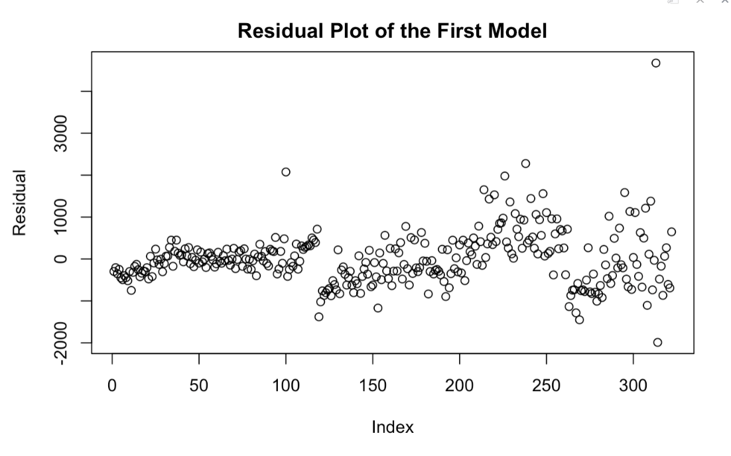

*Figure 9: The Residual Plot of the First Linear Model*

*Figure 10: The Residual Plot of the Second Linear Model*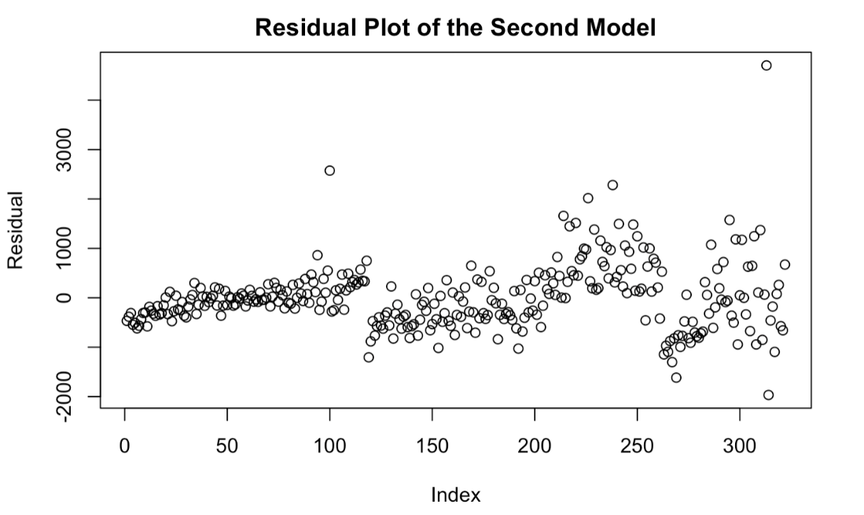

Model comparison is achieved by both ANOVA test and Akaike Information Criterion (AIC). The ANOVA test is basically checking whether the more complex model is a better fit compared to the simpler model. In this case, predictors of the second model are just a subset of the first one. Thus, we are testing whether adding more predictors to the model will give us better results. The p-value of the ANOVA test is 0.003, which is less than 0.05. Therefore, we conclude that the first model is a better fit. The AIC estimates the out-of-sample error of the model. Thus, the model with smaller AIC will be preferred. The AIC of the first model is 5094.798 and the AIC of the second model is 5102.599. Thus, we would prefer the first model. Based on both the ANOVA test and the AIC, the first linear model is a better fit of the data in this case.

**Conclusions**

Based on this research, we determined that patents tend to reflect the larger economic conditions of the period. That is when the economy is doing better, patent applications tend to increase and abandonments will decrease. Perhaps this observation is due to positive economic outlook, which combined with the growing threat of competition makes the requirement for patents more important. To the contrary, this study has shown that worsening economic conditions tend to result in more patent abandonments. Another possible conclusion that could be drawn from this data is the relevancy of the patents to the technology and electronic industries during the information age. We observed that the length of time that it takes a patent to be approved in those industries, soar from 29 months in 1995 to nearly 43 months in 2000. Considering the rate of advances in the computing industry, this would make the technology more than obsolete by the time it is patented. This evidence supports some of preliminary research that patents have fallen out of favor with companies operating in the technology sector (Moser, 2013).

Another point of interest, though not thoroughly investigated due to the limited scope of this study, was an observed growth in patent abandonments around 1998, which is prior to the start of the Dot-Com Bust. Perhaps this is an indicator of economic health that could better predict the next economic downturn, especially if a future bubble is so heavily predicated upon a single sector. Regardless, what this study has demonstrated is that patent trends fluctuate with the larger economic environment, but the exact relationship between the two remains unknown. While this study and others have evaluated this theory, the typical goal attempts to identify the factor—or factors—that drive patent trends or incentive effort. This study could offer support for two or three different theories, but it mostly points to a combination of market demand and inspiration from a new invention. The Dot-Com Bubble is marked by the rise of computing technology supported—at least in the United States—by a massive influx of foreign and direct investment. The extensive commercialization of the microchip and the myriad of new technology rooted in its creation is a sound explanation for the rise in innovation and the subsequent economic boom.

On the contrary, following each economic bubble is a period of financial bust. By 2004, the price of investment in the field of technology skyrocketed, investment slowed, and the economic bust quickly followed. While a definitive decline in technological development cannot be made confirmed, patent trends would indicate that such an event likely occurred. That is, through the clear evidence of reduced patent applications and increased abandonments, one could make a case for an innovation slowdown. However, the reality is likely more complex. Many economists were skeptical of the economic policy enacted during the period of the Dot-Com bust and believe that it propelled the plummeting investment levels and, therefore, inventive slowdown. Other economists argued there was not much slowdown in invention, if any at all. Technology and, in turn, productivity have grown and improved at an explosive rate since the start of the Dot-Com Bubble. The speed of technological innovation makes it a complex trend to capture using any one line of reasoning. As the rate of development of new technology increased, so did the wait time for patents. This natural relationship made them costly to obtain and enforce in a period when investment in future innovation would likely yield greater rewards.

In summary, there is definite support in the display of patent trends for a relationship between patents, invention, and economic prosperity. The extent and balance of this relationship, however, is very complex. The massive inflow of United States net investment (market demand) or the rapid commercialization of the microchip could have both catalyzed the innovative and economic boom. Patent trends could provide evidence in either case, but deeper research is necessary for any definite conclusions on these details. What can be clearly seen this study is that there is an interesting relationship between the patent, invention, and economic growth.

References

Hall, B., Jaffe, A., & Trajtenberg, M. (2001). *The nber patent citation data file: Lessons, insights and methodological tools* (No. w8498; p. w8498). https://doi.org/10.3386/w8498

Kraay, A., & Ventura, J. (2005). *The dot-com bubble, the bush deficits, and the U.S. Current account*. https://doi.org/10.1596/1813-9450-3672

Moser, P. (2013). Patents and innovation: Evidence from economic history. *Journal of Economic Perspectives*, *27*(1), 23–44. https://doi.org/10.1257/jep.27.1.23

Patents View: Data Download Tables [Government]. (2019, October 8). Retrieved December 2, 2019, from United States Patent and Trade Office website: https://www.patentsview.org/download/

Appendix A

Summary Statistics for Patent Data Set

|  |  |  |  |  |  |
| --- | --- | --- | --- | --- | --- |
|  | Minimum | Median | Mean | Std. Dev. | Maximum |
| **AgFoodTextiles** | 32 | 65 | 67.13 | 2.45E+8 | 251 |
| Pending_Change | -2143 | -1 | -5.519 | 18.176 | 157 |
| Issued_Patents | 8 | 43 | 42.49 | 121.1377 | 103 |
| Abandoned_Patents | 5 | 24 | 23.37 | 14.5643 | 54 |
| InUse_Change | -100 | -13.5 | -15.59 | 9.199 | 60 |
| **Coating** | 137 | 260.5 | 262.2 | 23.4441 | 642 |
| Pending_Change.1 | -11334 | 20 | -10.33 | 57.2466 | 421 |
| Issued_Patents.1 | 54 | 138 | 145.8 | 636.7358 | 307 |
| Abandoned_Patents.1 | 32 | 82 | 92.06 | 43.0801 | 241 |
| InUse_Change.1 | -93 | 12.5 | 21.25 | 38.8934 | 215 |
| **Gas** | 27 | 68 | 71.84 | 49.6754 | 145 |
| Pending_Change.2 | -2790 | 5.5 | -2.904 | 23.4782 | 82 |
| Issued_Patents.2 | 14 | 42 | 47.79 | 157.6234 | 145 |
| Abandoned_Patents.2 | 3 | 16 | 18.42 | 21.9085 | 46 |
| InUse_Change.2 | -49 | 7 | 7.957 | 9.0372 | 117 |
| **Organic** | 193 | 401 | 413.9 | 28.2788 | 1742 |
| Pending_Change.3 | -11168 | 4.5 | -25.18 | 102.1948 | 1253 |
| Issued_Patents.3 | 96 | 243 | 248.3 | 632.4962 | 443 |
| Abandoned_Patents.3 | 63 | 150.5 | 156 | 58.6982 | 304 |
| InUse_Change.3 | -704 | -38.5 | -78.57 | 52.4093 | 234 |
| **Resins** | 335 | 488.5 | 498.8 | 146.8528 | 2119 |
| Pending_Change.4 | -15924 | 12 | -22.23 | 121.976 | 1510 |
| Issued_Patents.4 | 95 | 289 | 292.1 | 898.1412 | 582 |
| Abandoned_Patents.4 | 75 | 170 | 179.9 | 70.0855 | 369 |
| InUse_Change.4 | -352 | 13.5 | 12.67 | 65.7772 | 374 |
| **Chemical_Misc** | 968 | 1452 | 1468 | 98.6906 | 3443 |
| Pending_Change.5 | -58413 | 91.5 | -72.47 | 219.3382 | 1898 |
| Issued_Patents.5 | 394 | 816.5 | 855.4 | 3271.162 | 1671 |
| Abandoned_Patents.5 | 208 | 501 | 504.1 | 200.5872 | 1056 |
| InUse_Change.5 | -739 | -2.5 | 24.64 | 154.0118 | 1054 |
| **Communications** | 334 | 1932 | 1813.9 | 273.5747 | 5100 |
| Pending_Change.6 | -115111 | 256 | -18.26 | 978.8326 | 1918 |
| Issued_Patents.6 | 219 | 898.5 | 1064.9 | 6454.779 | 3548 |
| Abandoned_Patents.6 | 58 | 317 | 412.7 | 737.6445 | 1533 |
| InUse_Change.6 | -75 | 611 | 682.8 | 298.5561 | 2802 |
| **Comp_Hardware_Softwa** | 307 | 1822.5 | 1736.5 | 605.9698 | 6577 |
| Pending_Change.7 | -133049 | 264 | -12.25 | 1068.755 | 3346 |
| Issued_Patents.7 | 148 | 780 | 938.5 | 7454.734 | 3403 |
| Abandoned_Patents.7 | 79 | 248 | 397.5 | 717.5213 | 1601 |
| InUse_Change.7 | -30 | 565.5 | 663.1 | 308.8706 | 2790 |
| **Comp_Peripherals** | 91 | 671.5 | 673.7 | 571.5743 | 2121 |
| Pending_Change.8 | -46575 | 119.5 | -3.34 | 398.0746 | 808 |
| Issued_Patents.8 | 49 | 371.5 | 376.6 | 2609.613 | 1113 |

Appendix B

R Code Script

All code developed for this study can be accessed in the following file:

ANLY511_Patent Analysis Script.rmd